Software Engineering Group Projects
English Tutor
Design Specification

Author: Group 3
Config Ref: SE.QA.03
Date: 17th May 2012
Version: 2.1
Status: Released

Department of Software Engineering College
NorthEastern University
ShenYang
HePing
WenHua Road 14
Copyright © NorthEastern University 2012

CONTENTS

1. INTRODUCTION 3
1.1 Purpose of this Document 3
1.2. Scope 3
1.3. Objectives 3
2. DECOMPOSITION DESCRIPTION 3
2.1 Programs in system 3
2.2 Significant classes in Program 3
2.3 Mapping from requirements to classes 4
3. DEPENDENCY DESCRIPTION 5
3.1 Component Diagram for Program 5
3.2 Inheritance Relationships 5
4. INTERFACE DESCRIPTION 6
5. DETAILED DESIGN 11
5.1 Sequence diagrams 11
5.2 Significant algorithms 12
5.3 Significant data structures 13
6. REFERENCES 15
7.DOCUMENT CHANGE HISTORY 16

1. INTRODUCTION

1.1 Purpose of this Document
The purpose of this document is to show our design of our project in details, including decomposition description, dependency description, interface description and detailed design.

1.2. Scope
The purpose of this document is to show our design of our project. It does not cover the UI design, and Test design.
This document is in accordance with the quality standards specified in QA.03 [1] and QA.05a [2].

1.3. Objectives
to indicate the functionality of the program in our project
to indicate the dependency of the components in our project
to specify the public interface of the classes in our project
to specify the important sequences, difficulty algorithms and significant data structure in our project.

2. DECOMPOSITION DESCRIPTION

2.1 Programs in system
Our system has only one program, whose usage is to help people to learn English. It can learn and test phrase, and add, delete, modify the phrases in the lesson.

2.2 Significant classes in Program
MainController: this class controller the action of main window, pass data to LessonController, LearnController, TestController and so on.
LessonController: show the phrases of the specific lesson, add, delete and modify the phrases in the lesson.
LearnController: help the user to learn the phrase in the lesson.
TestController: provide the logic to test 10 random phrases.
Database: the model store the data.

2.3 Mapping from requirements to classes

Functional Requirements | Classes providing
FR1 Establishing identity of user | LoginController, LoginFrame, Datebase
FR2 Starting to use the software (New User) | LoginController, LoginFrame, Datebase
FR3 Starting to use the software (Existing User) | MainController, MainFrame, LoginController, LoginFrame, Datebase, LessonController
FR4 Learning a lesson | MainController, MainFrame, LearnController, LearnFrame, Lesson, Phrase
FR5 Test for a lesson | MainController, MainFrame, TestController, TestFrame, Lesson, Phrase
FR6 Test for all lessons learned so far | MainController, MainFrame, TestController, TestFrame, Account, Phrase
FR7 Lesson management | LessonController, LesssonFrame, Lesson, Phrase

3. DEPENDENCY DESCRIPTION

3.1 Component Diagram for Program
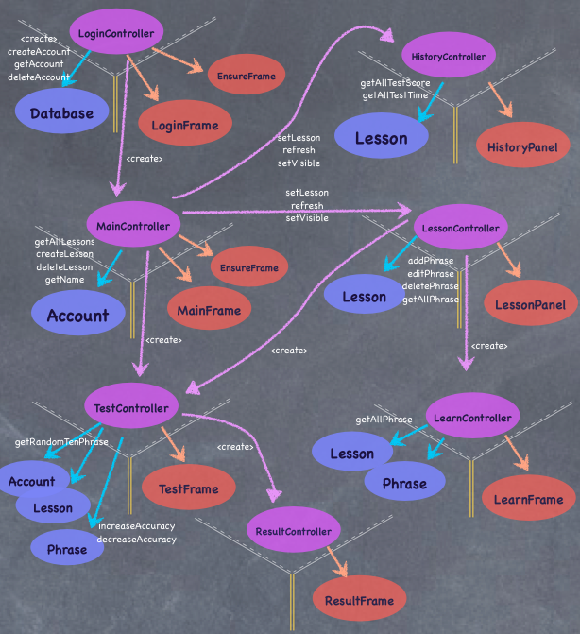
Figure 1: For simplicity and readability, we omit some simple getter and setter of models and view, which can be seen in UML class diagram in Section 5 without difficulty and ambiguousness.

3.2 Inheritance Relationships
As shown in UML class diagram in Section 5, all frames, named MainFrame, LoginFrame, LearnFrame, TestFrame, ResultFrame, EnsureFrame, is inherited from AbstractFrame.

4. INTERFACE DESCRIPTION

Database
Constructor | Database()  Constructs a database.
Account | creatAccount(String name)  Create an account in the database.
void | deleteAccount(int index)  Delete an account from the database.
ArrayList<Account> | getAllAccount()  To get all the accounts of the database.

Account
Constructor | Account(String name)  Construct a account with its name.
String | getName()  To get the name of the account.
void | deleteLesson(int index)  To delete the lesson the account,
void | createLesson(String name)  To create a lesson in the account.
ArrayList<Lesson> | getAllLessons()  To get all the lessons of the accout.
ArrayList<Phrase> | getRandomTenPhrases()  To get ten phrases randomly.
String | toString()  Return the name of the account.

Lesson
Constructor | Lesson(String accountName, Connection connection, String lessonName)  Constructa a lesson with its account name and lesson name.
void | addPhrase(Phrase phrase)  Add a phrase into the lesson.
void | editPhrase(int index)  Edit the phrase in the lesson
void | deletePhrase(int index)  Delete a phrase from the lesson.
ArrayList<Phrase> | getAllPhrase()  To get all the phrases of the lesson.
ArrayList<Phrase> | getRandomTenPhrase()  Get ten phrases randomly.
int | getPhraseCount()  Get the number of the phrases in the lesson.
Phrase | getPhrase(int row)  Get the phrase in the lesson.
void | addTestResult(String time,int score)  Add a test result into the lesson
ArrayList<String> | getAllTestScore()  To get all the test scores of this lesson.
ArrayList<int> | getAllTestTime()  To get all the test’s time of this lesson.

Phrase
Constructor | Phrase(String English,String Chinese,String Audio)  Construct a phrase wih its English ,Chinese and audio.
void | setEnglish(String english)  Set the English of the phrase.
void | setChinese(String Chinese)  Set the Chinese of the phrase.
void | setAudio(String audio)  Set the audio of the phrase.
String | getEnglish()  Get the English of the phrase.
String | getChinese()  Get the Chinese of the phrase.
String | getAudio()  Get the audio of the phrase.
void | setLastReviewTime(String time)  Set the last review time of the lesson.
String | getLastReviewTime()  Get the last review time of the lesson.
int | getAccuracy()  Get the accuracy of the lesson.
void | increaseAccuracy()  Increase the accuracy of the lesson by one.
void | decreaseAccuracy()  Decrease the accuracy of the lesson by one.

MainController
Constructor | MainController(Account account)  Construct a main cotroller with its account.
void | setAccount(Account account)  Set the account of the main controller now.
void | setVisible(Boolean isVisible)  Set the Boolean value of the visible of the main controller.
void | refresh()  Refresh the state of the main controller.

LoginController
void | run()  To run the login program.

LearnController

LessonController
Constructor | LessonController(Lesson lesson)  Construct a lesson controller with a lesson.
void | setLesson(Lesson lesson)  To set the current lesson.
void | refresh()  To refresh the state of the lessonFrame.
void | setVisible(boolean isVisible)  To set whether the lesson panel is visible.

ResultController

HistoryController
Constructor | HistoryController(Lesson lesson)  Construct a history controller with its lesson.
void | setLesson(Lesson lesson)  Set the current lesson of the history record.
void | refresh()  Refresh the state of the history panel
void | setVisible()  Set the visible state of the history panel.

TestController
Construtor | TestController()  Construct a test controller
void | testLesson(Lesson lesson)  Test the lesson.
void | testAccount(Account accout)  Test the account.

AbstractFrame
JButton | getExitButton()  Get the exit button of the frame.
JButton | getShrinkButton()  Get the Shrink button of the frame.
void | setBackgroundImage(String filePath)  Get the background image of the frame.

MainFrame extends from AbstractFrame
JTable | getLessonsTable()  Get the lessons table of the main frame.
JButton | getPhraseListButton()  Get the JButton of the main frame.
JButton | getHistoryPandButton()  Get the history button of the main frame.
JButton | getAddLessonButton()  Get the add lesson button of the main frame.
JButton | getDeleteLessonButton()  Get the delete lesson button of the main frame.
JButton | getLogoutButton()  Get the logout button of the main frame.
JButton | getTestAllButton()  Get the test all button of the main frame.

ResultFrame extends from AbstractFrame
JTable | getResultTable()  Get the result table of the result frame.
JLabel | getTitleLabel()  Get the title label of the result frame.
JButton | getRetryButton()  Get the retry button of the result frame.
JButton | getFinishButton()  Get the finish button of the result frame.

EnsureFrame extends from AbstractFrame
JLabel | getStatementLabel()  Get the statement label of the ensure frame.
JButton | getFirstButton()  Get the first button of the ensure frame.
JButton | getSecondButton()  Get the second button of the ensure frame.
JButton | getThirdButton()  Get the third button of the ensure frame.

LoginFrame extends AbstractFrame
JLabel | getSummaryLabel()  Get the summary label of the login frame.
JButton | getCreateAccountButton()  Get the create account button of the login frame.
String | getAccountName()  Get the account name button of the login frame.
JList | getExistAccountList()  Get the exist account list of the login frame.

TestFrame extends AbstractFrame
JLabel | getTitleLabel()  Get the title label of the test frame.
JProgressBar | getProgressBar()  Get the progress bar of the test frame.
JButton | getNextButton()  Get the next button of the test frame.
JButton | getSoundButton()  Get the sound button of the test frame.
JLabel | getQuestionLabel()  Get the question label of the test frame.
JLabel | getCorrectAnswerLabel()  Get the correct answer label of the test frame.
JTextField | getAnswerTextField()  Get the answer text field of the test frame.

HistoryPanel
JTable | getHistroyTable()  Get the history table of the history panel.
JLabel | getTitleLabel()  Get the title label of the history panel.

LearnFrame
JLabel | getTitleLabel()  Get the title label of the learn frame.
JTable | getPhraseTable()  Get the phrase table of the learn frame.
JButton | getRetryButton()  Get the retry button of the learn frame.
JButton | getFinishButton()  Get the finish button of the learn frame.

LessonPanel
JLabel | getLastReviewLabel()  Get the last review label of the lesson panel.
JTable | getPhraseTable()  Get the phrase table of the lesson panel.
JButton | getTestLessonButton()  Get the test lesson button of the lesson panel.
JButton | getLearnLessonButton()  Get the learn lesson button of the lesson panel.
JTextField | getEnglishTextField()  Get the English text field of the lesson panel.
JTextField | getChineseTextField()  Get the Chinese text field of the lesson panel.
JLabel | getTitleLabel()  Get the title label of the lesson panel.
JButton | getAddPhraseButton()  Get the add phrase button of the lesson panel.
JButton | getDeletePhraseButton()  Get the delete phrase button of the lesson panel.

5. DETAILED DESIGN

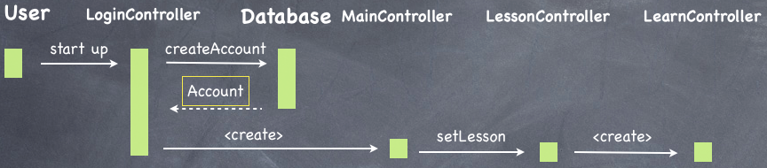
5.1 Sequence diagrams
Figure 2:create a new account and start learning Lesson 1
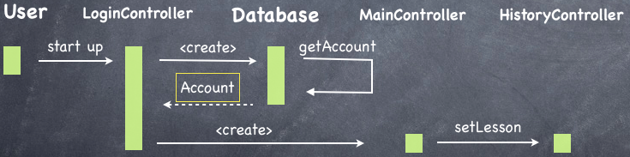
Figure 3:select a existing account and check Lesson 1 test history 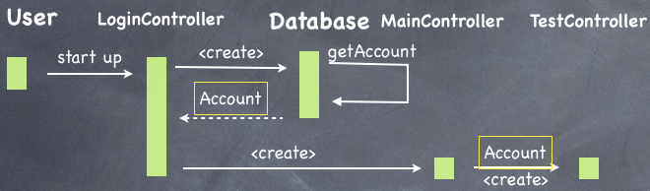
Figure 4:select a existing account and test learning Lesson 1 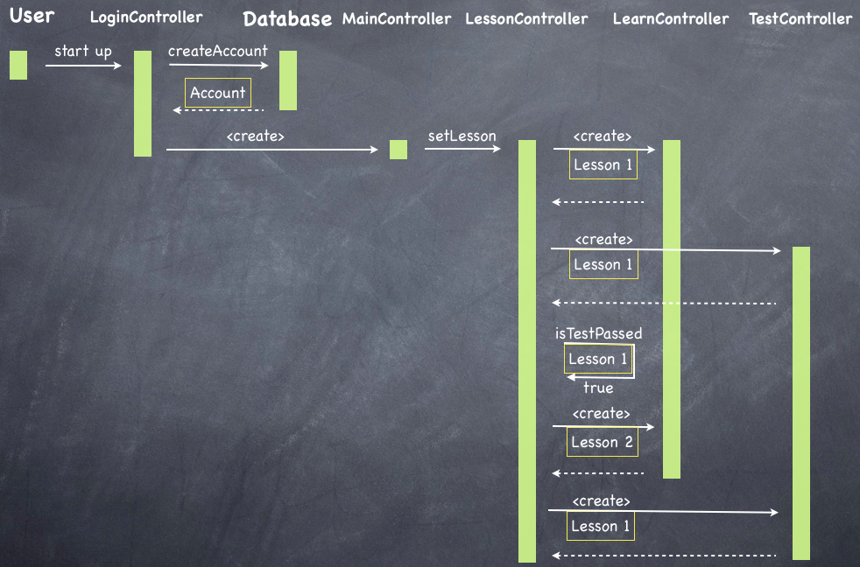
Figure 5:create a new account and test Lesson2(must previously finish learning, testing Lesson1 and learning Lesson 2)

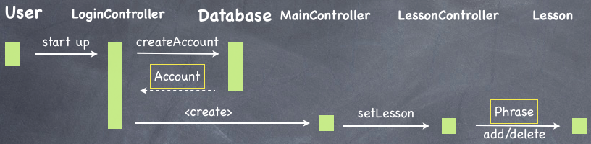
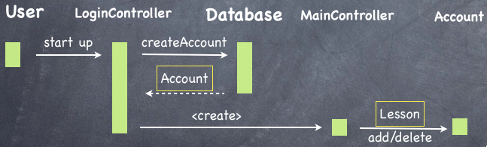
Figure 6: add or delete phrase
Figure 7: add or delete lesson

5.2 Significant algorithms
Actually there exists two difficult parts of our project. I will show as following.
The first part is how to store or retrieve user data and default lessons for new user in the disk. There will be lots of ways to implement this kind of function. Our project chooses store the user data through Sqlite and store the default lessons in XML file. Sqlite query data very fast and easily manipulate, which we need indeed. Dealing with the connection with Java and Sqlite, we use a open source JAR, named SqliteJDBC, under a BSD license. With that, we can easily insert, query, update and delete data. We choose to use XML because of its simplicity, generality, and usability.
The second part is that, for more appealing UI, we undecorated the JFrame and reimplement our own look of the frame and some action handling. With the help of oracle tutorial, we have built a translucent frame with our own background image. That tutorial have use com.sun.awt.AWTUtilities class, however, this class change drastically between update releases. We won't use it for better maintenance in the future.

5.3 Significant data structures
We show four diagrams to explain the relationship between classes or objects. For readibility, we omit the relationship between MVCs, which can be seen easily from Component Diagram(Figure 1)

Figure 8: Class Diagram for controllers
Figure 9: Class Diagram for views

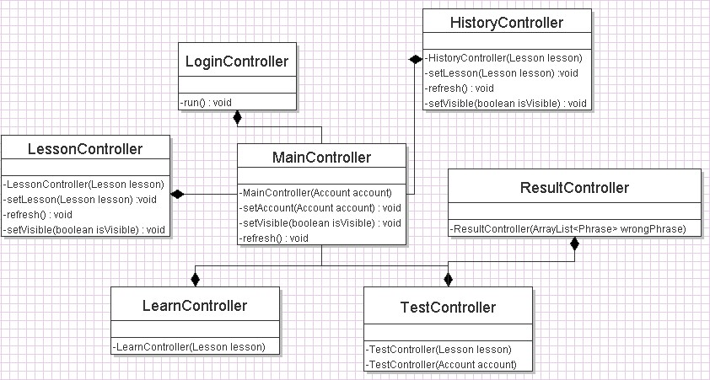
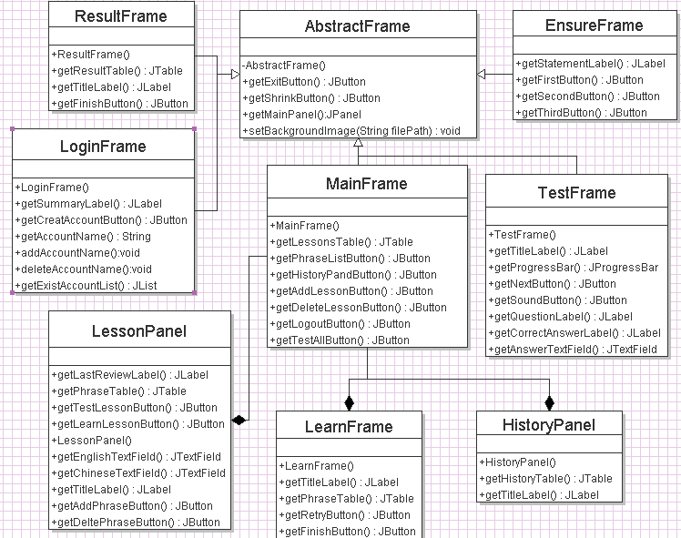

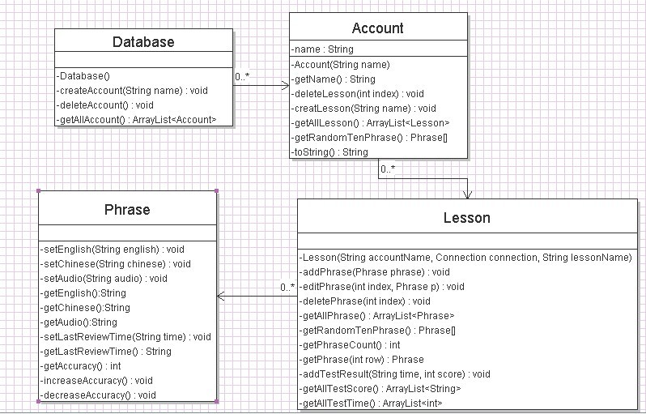
Figure 9: Class Diagram for models

Figure 11: Object Diagram: we show the relationship between the objects in the real program

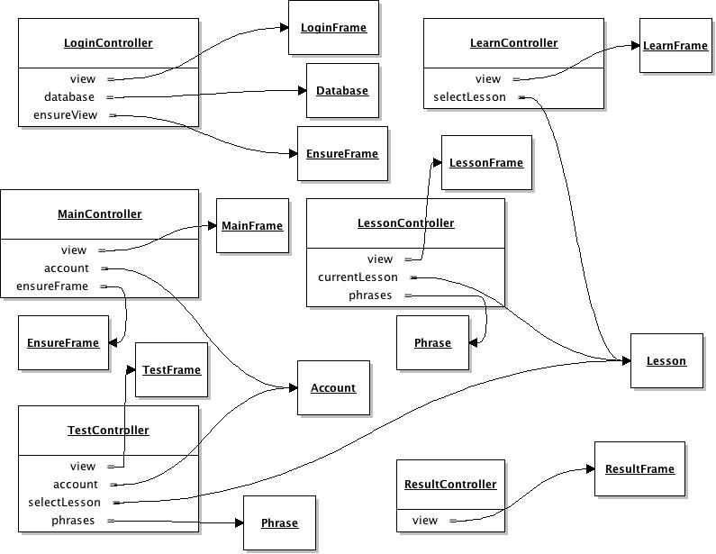

6. REFERENCES
[1] QA Document SE.QA.03 - General Documentation Standards.
[2] QA Document SE.QA.05a - Design Specification Standards.

7. DOCUMENT CHANGE HISTORY
Version | Date | Changes | Changed By
1.0 | 2012/5/17 | Document given complete overhaul in Word | CJW, YLF, LYS
1.2 | 2012/5/18 | Add Component Diagram | CJW
2.1

